Day 14 – SQL Sales Analysis (Coding Challenge)

Q&A
- Show all records from the Sales table.
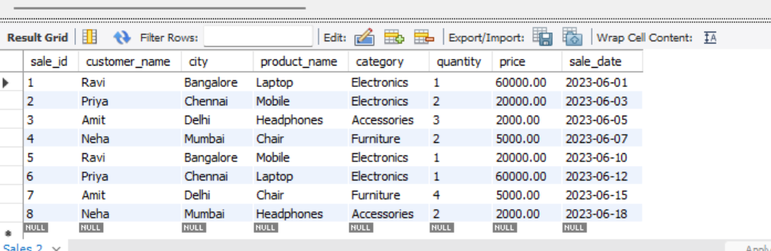

- Display only customer names and cities.
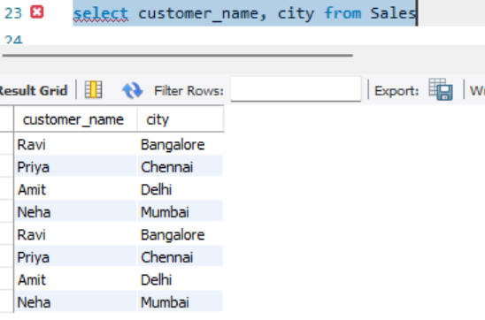
- Show product name and price.
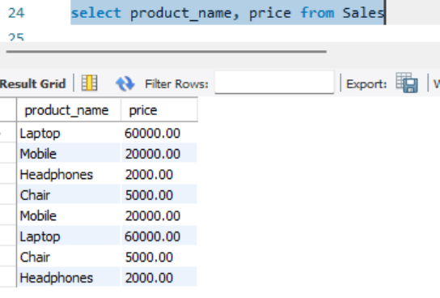

- Show all sales where city is 'Bangalore'.
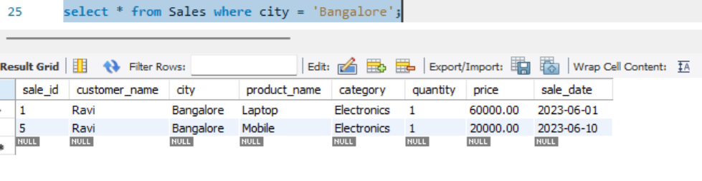

- Find all products in 'Electronics' category.
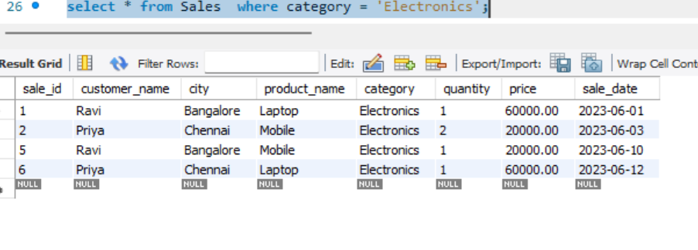

- Show sales where price is greater than 10,000.
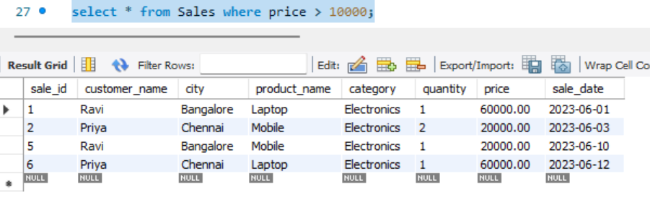
- Display sales where quantity is more than 2.
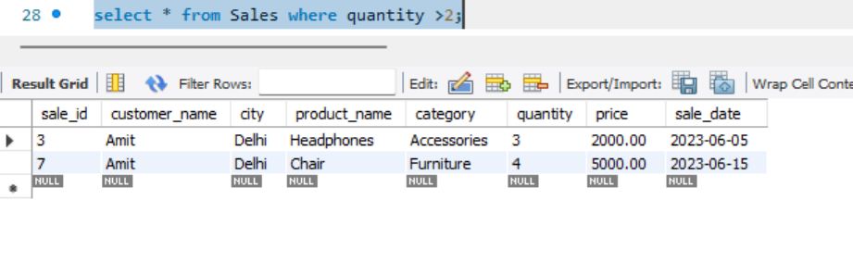

- Show all sales sorted by price (low to high).
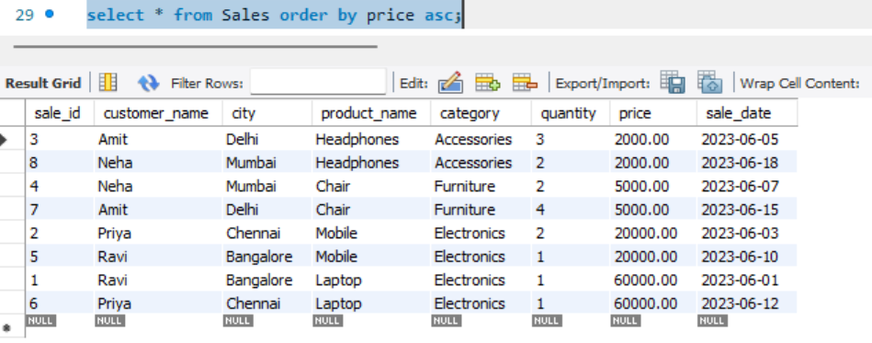
- Display sales sorted by quantity (high to low).
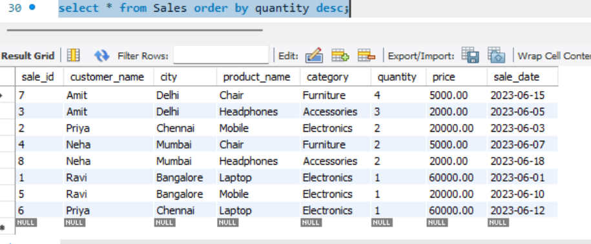
- Show unique cities.
